23. Create procedure adding a department inserting a row.

Create table:

CREATE TABLE dept (

department_id NUMBER(4) PRIMARY KEY,

department_name VARCHAR2(30)

);

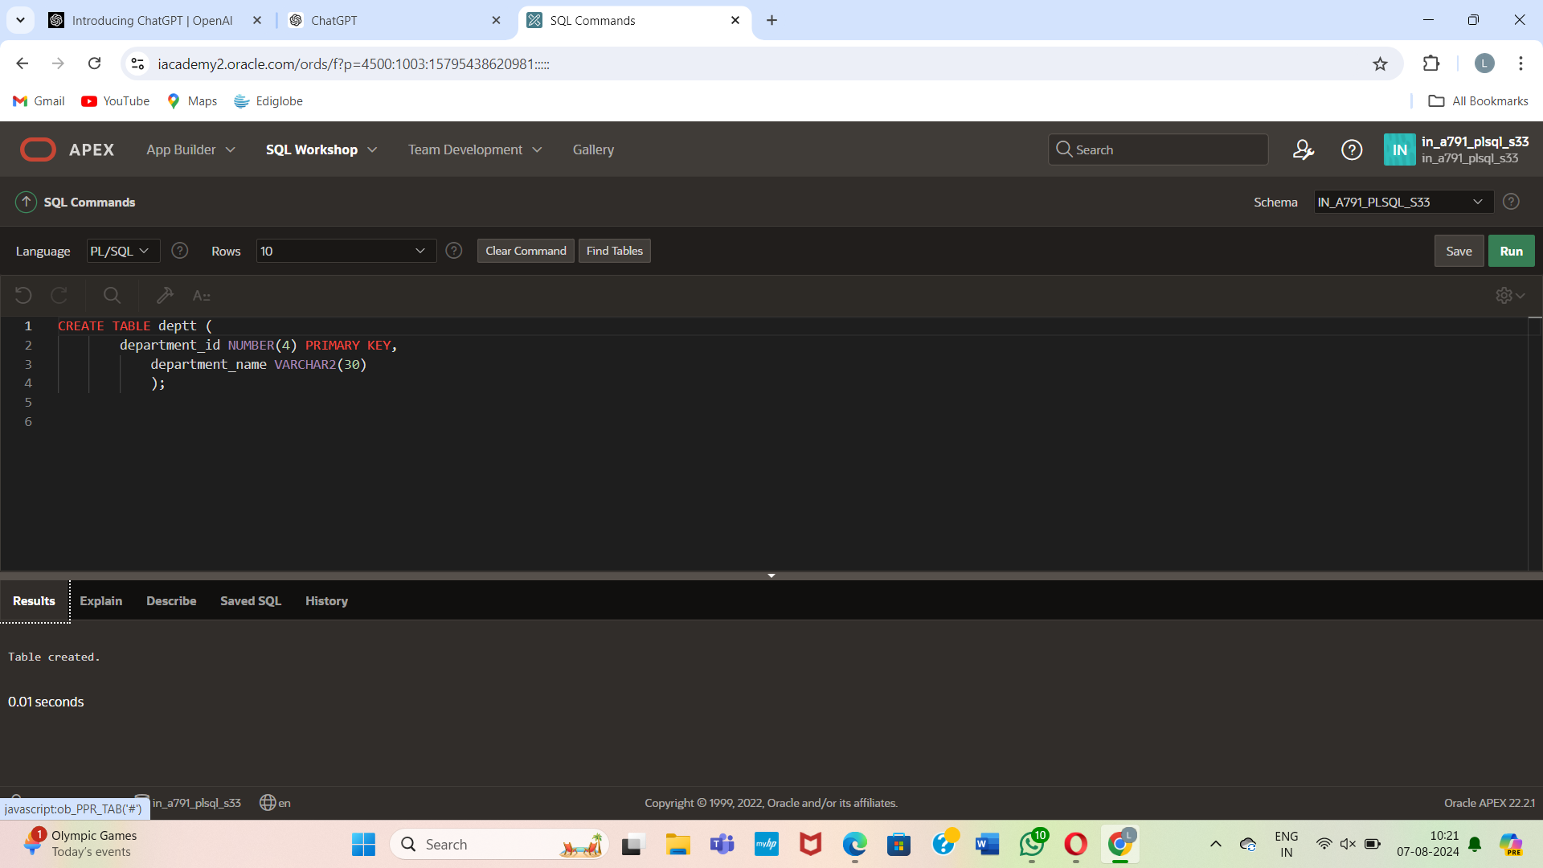

Insert values:

INSERT INTO dept (department_id, department_name) VALUES (100, 'Human Resources');

INSERT INTO dept (department_id, department_name) VALUES (200, 'Finance');

INSERT INTO dept (department_id, department_name) VALUES (300, 'Marketing');

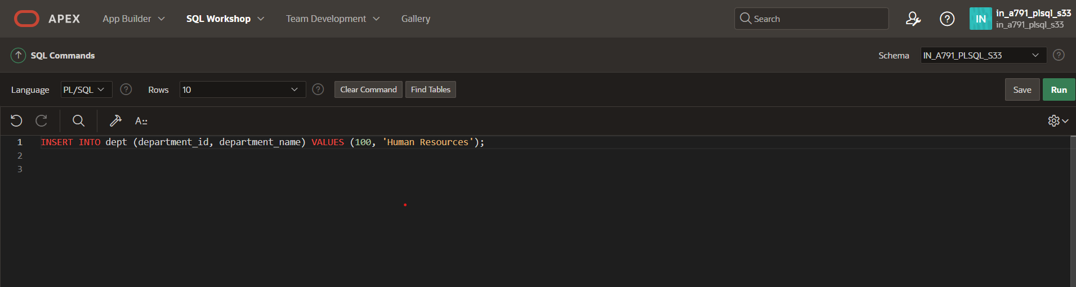

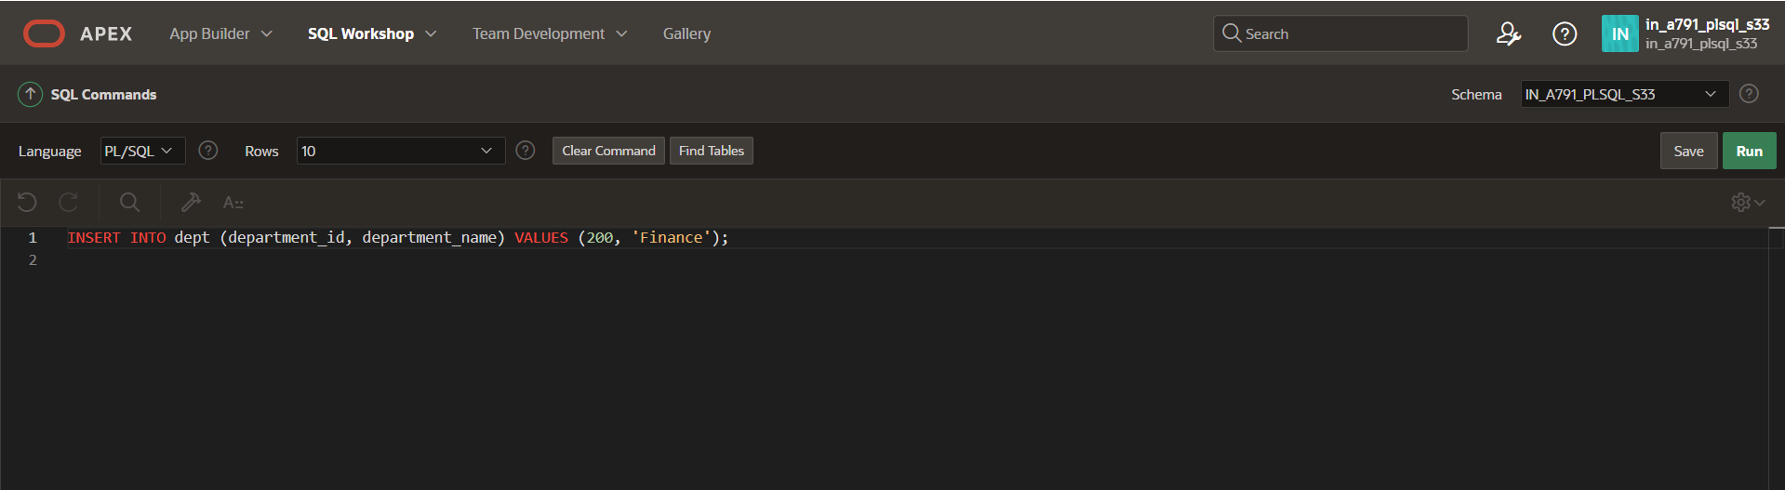

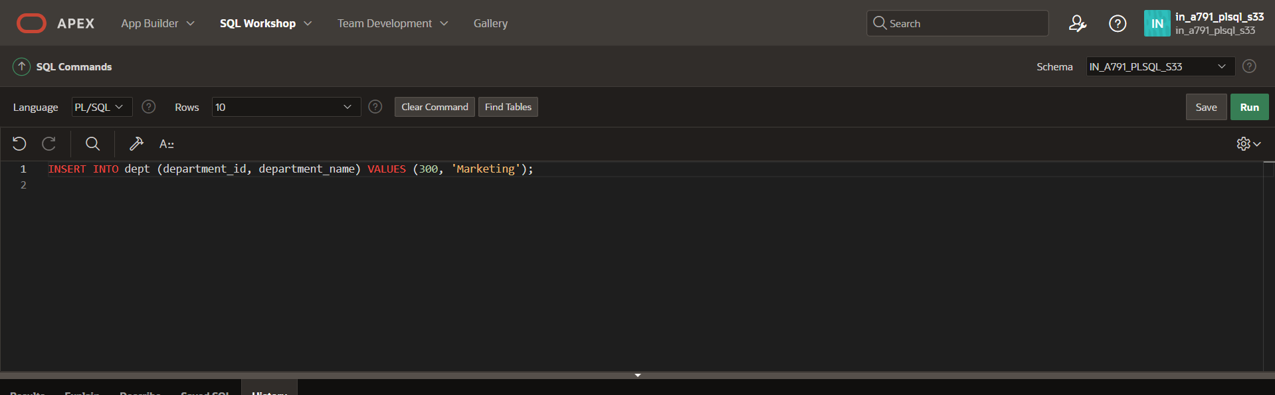

Create procedure:

CREATE OR REPLACE PROCEDURE add_dept IS

v_dept_id dept.department_id%TYPE;

v_dept_name dept.department_name%TYPE;

BEGIN

v_dept_id := 280;

v_dept_name := 'ST-Curriculum';

INSERT INTO dept(department_id, department_name)

VALUES(v_dept_id, v_dept_name);

DBMS_OUTPUT.PUT_LINE('Inserted ' || SQL%ROWCOUNT || ' row.');

END;

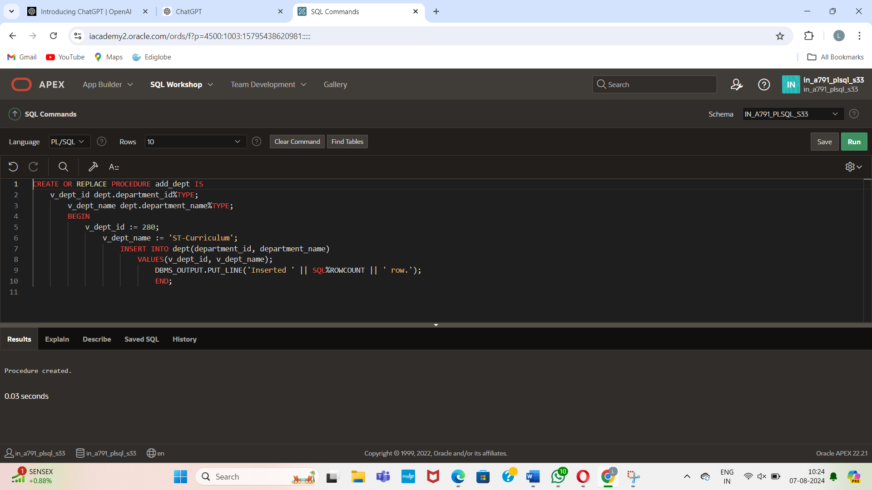

After adding a row:

Output:

